
February monthly report
Project Title:
Conversion of post-combustion gas from cement manufacturing to syngas by electrochemical CO₂ capture and reduction
……..........................................................
Dr. Pongkarn Chakthranont
Sothearoth Heng
NCR ID: 803198
Under the supervision of
Dr. Pongkarn Chakthranont
Contract Number: NCR-NN-2024-22237-EN
February 2025

- Tasks list for February
- Long-term stability under high CO₂ conversion conditions (diluted and pure CO₂ conditions with lower flow rates)
- Long-term stability under SFG conditions at 200mA/cm²
- Experimental Procedure
Long-term stability of CO₂ electrolysis
A 5 cm² MEA electrolyzer was used to evaluate the CO2RR performance under modulated operating conditions. The Ni foam, bipolar membrane (BPM), and different cathode catalysts were employed as the anode, membrane, and cathode electrode, respectively. 500 ml of 0.5 KOH was recirculated and used throughout the experiment as the anolyte at 8 ml/min. The KOH electrolyte was refreshed every 24h, while the NiSAC cathode was also flushed with 10ml of DI water. The humidified CO₂ gas stream was introduced into the cathodic inlet under total flow rates of 10 ml/min. Meanwhile, the cathodic outlet was directly injected into an online gas-chromatography for gas products analysis.

- Results
Long-term CO₂ electrolysis of Ni0.5SAC under 20ml SFG with 0.25M KOH and IrO₂-TiPt mesh at 100-200mA/cm²
This figure presents data from CO₂ electrolysis experiments conducted at current densities of 100 mA/cm² (left) and 200 mA/cm² (right) using a 20 ml SFG feed (15% CO₂, 5% O₂, 80% N₂) in 0.25M KOH with an IrO₂-TiPt anode. The graphs show the Faradaic efficiency (FE) for CO (green) and H₂ (pink) production, along with cell voltage over time. At 100 mA/cm², CO formation remains low (< 20%) while H₂ production gradually increases, and the single-pass CO₂ utilization (SPU) is 28%, indicating poor efficiency due to higher ORR activity. In contrast, at 200 mA/cm², CO formation is initially higher but decreases slightly, while H₂ production remains relatively stable, leading to a much higher SPU of 92% with total FE(CO+H2) around 80%, suggesting significantly improved efficiency in terms of suppressing ORR activity. The cell voltage rises in both cases, from ~3V to 4V over 24 hours at 100 mA/cm² and from ~3.5V to 4.5V within 2 hours at 200 mA/cm². These results indicate that increasing the current density greatly improves power utilization efficiency, although the long-term stability of CO₂ electrolysis must be further improved.
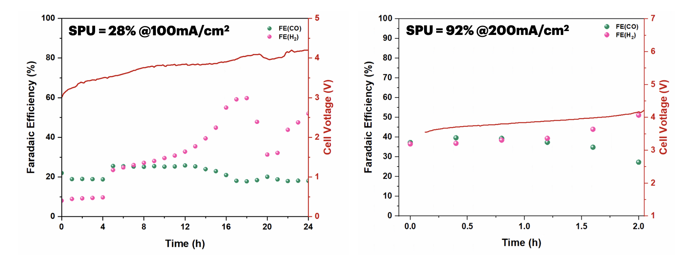
Figure 1. CO₂ electrolysis under 20ml of SFG (15%CO₂,5%O₂,80%N₂) feed with 0.25M KOH and IrO₂-TiPt anode at 100 and 200mA/cm²

This figure illustrates the effect of different diluted 15%CO₂ flow rates (100 ml/min, 50 ml/min, and 30 ml/min) at a constant current density of 200 mA/cm² on CO₂ electrolysis performance. As the total flow rate of 15%CO₂/85%N₂ decreases from 100 ml/min to 30 ml/min, the FE for CO marginally decreases, indicating poor CO selectivity under lower CO2 concentration, while the FE for H₂ remains relatively stable with a slight decline. The single-pass utilization (SPU) improves significantly, increasing from 36% at 100 ml/min to 95% at 30 ml/min with a short operational duration. This trend suggests a tradeoff between SPU and stability of the overall cell system under various CO₂ supply.

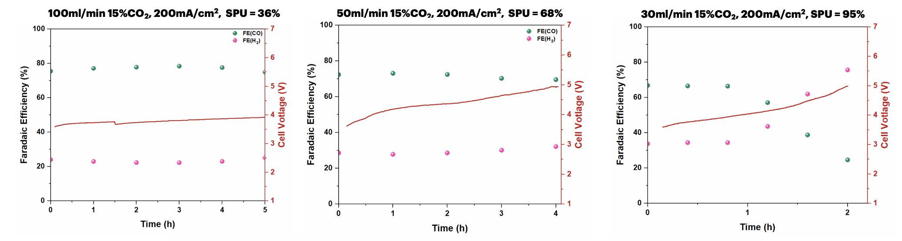
Figure 2. CO₂ electrolysis under different flow rates of 15%CO₂/85%N₂ feed with 0.25M KOH and IrO₂-TiPt anode at 200mA/cm²

Influence of CO₂ supply on single-pass utilization (SPU) at 200mA/cm²
In order to determine the carbon efficiency of the CO₂ electrolysis system, we study the impact of CO₂ supply on selectivity and SPU. At 150 ml/min, CO₂ utilization is poor, leading to a low single-pass utilization (SPU) of just 5%, despite a high initial FE for CO. As the CO₂ flow rate is reduced to 10 ml/min, CO selectivity improves significantly, with FE(CO) remaining high, while the SPU increases to 62%. Further reducing the flow rate to 7.5 ml/min enhances the system efficiency even more, reaching an SPU of 90%, indicating optimal CO₂ utilization. The cell voltage remains relatively stable across all cases, though lower flow rates contribute to slightly lower voltages, suggesting improved energy efficiency. These results suggest that lowering the CO₂ flow rate enhances CO₂-to-CO conversion efficiency with a minimal FE(CO) drop from 98% to 88%. A key tradeoff between SPU and system stability emerges when optimizing CO₂ flow rates in electrolysis. While reducing the CO₂ flow rate significantly improves SPU—as seen in the 90% SPU at 7.5 ml/min—it may also introduce mass transport limitations, potentially affecting long-term operational stability. Lower flow rates enhance CO₂ utilization, reducing unreacted CO₂ losses and improving CO selectivity, but they may also lead to localized CO₂ depletion, pH fluctuations, and electrode degradation over extended operation, which could negatively impact stability. Conversely, higher flow rates (e.g., 150 ml/min, where SPU is only 5%) ensure a continuous CO₂ supply, maintaining a more stable reaction environment but at the cost of inefficient CO₂ usage and increased energy losses. A balanced tradeoff would involve selecting a moderate CO₂ flow rate (e.g., 10–30 ml/min), where SPU remains high (~60–80%) while ensuring adequate CO₂ availability for prolonged and stable operation without excessive CO₂ wastage.
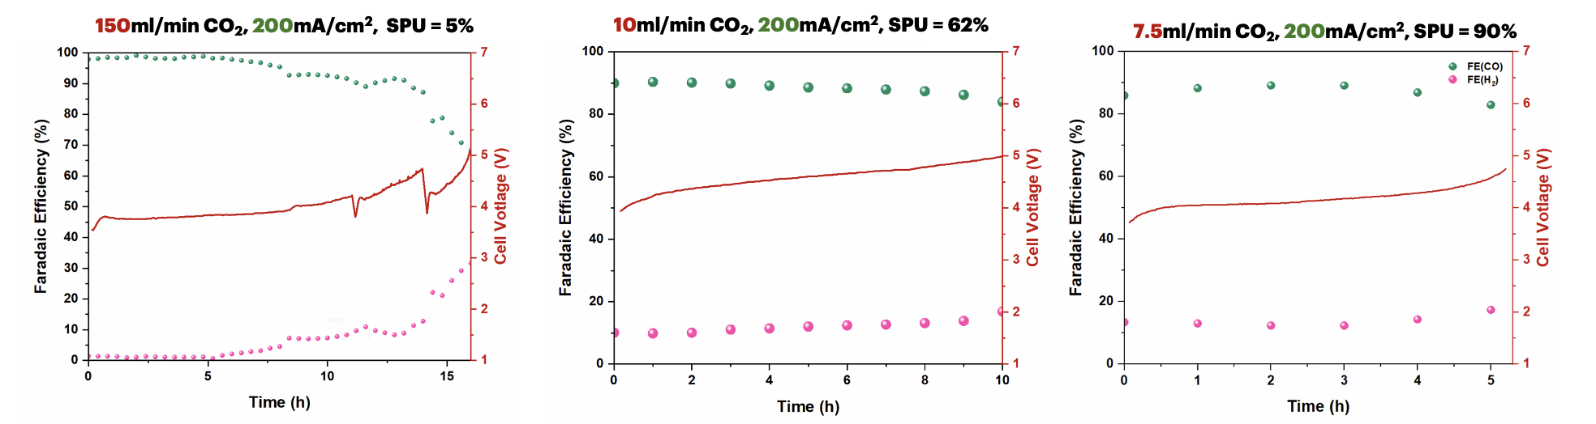
Figure 3. Long-term CO₂ electrolysis under different pure CO₂ flow rates (150, 10, and 7.5 ml/min) with 0.25M KOH and IrO₂-TiPt at 200mA/cm²

- Upcoming tasks
- Characterization of NiSACs
- Optimization of the 25cm² CO₂ electrolyzer operating condition:
  - Torque force
  - Cathodic/Anodic flow rate
  - Current density
  - Catalyst mass loading

